K-V Reale Trailer I



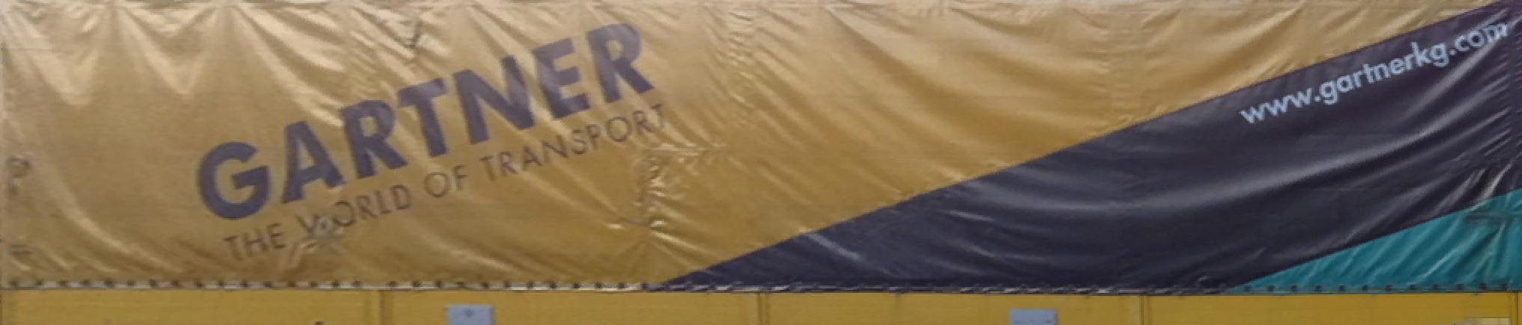

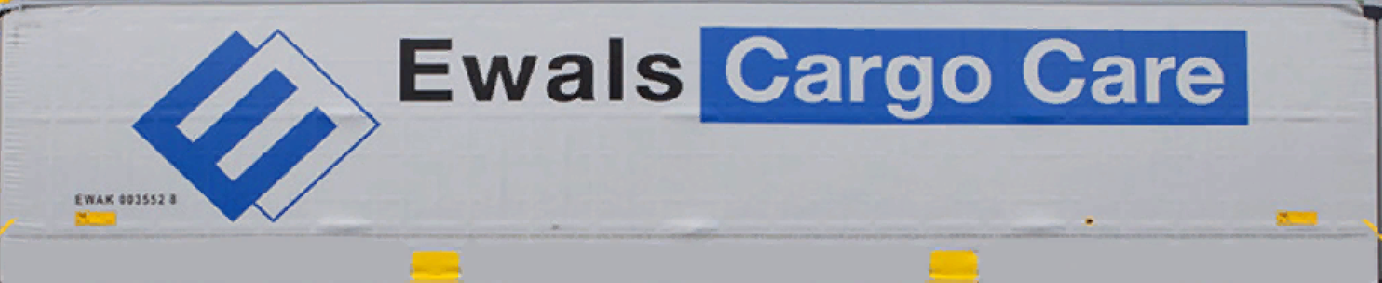

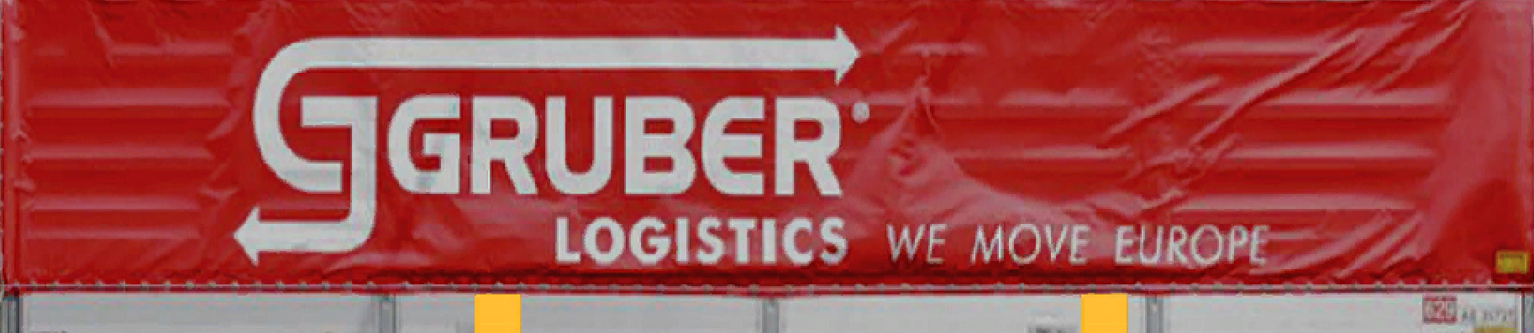

K-V Reale Trailer II

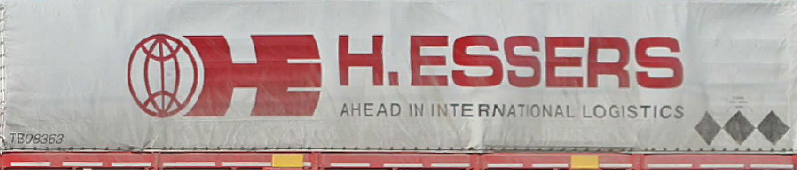

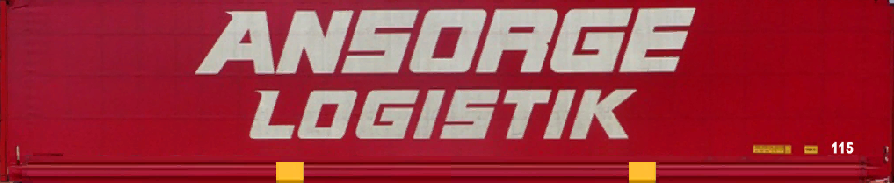

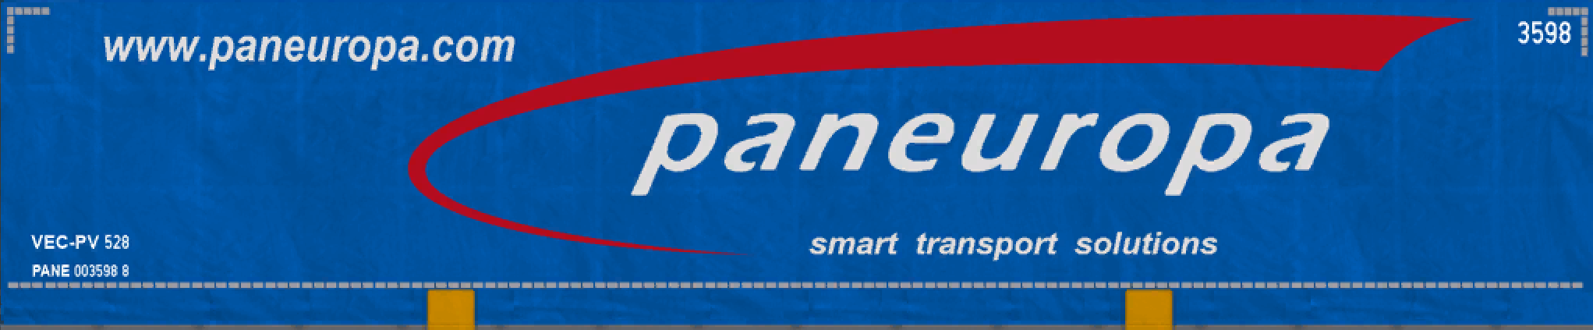



K-V default Front





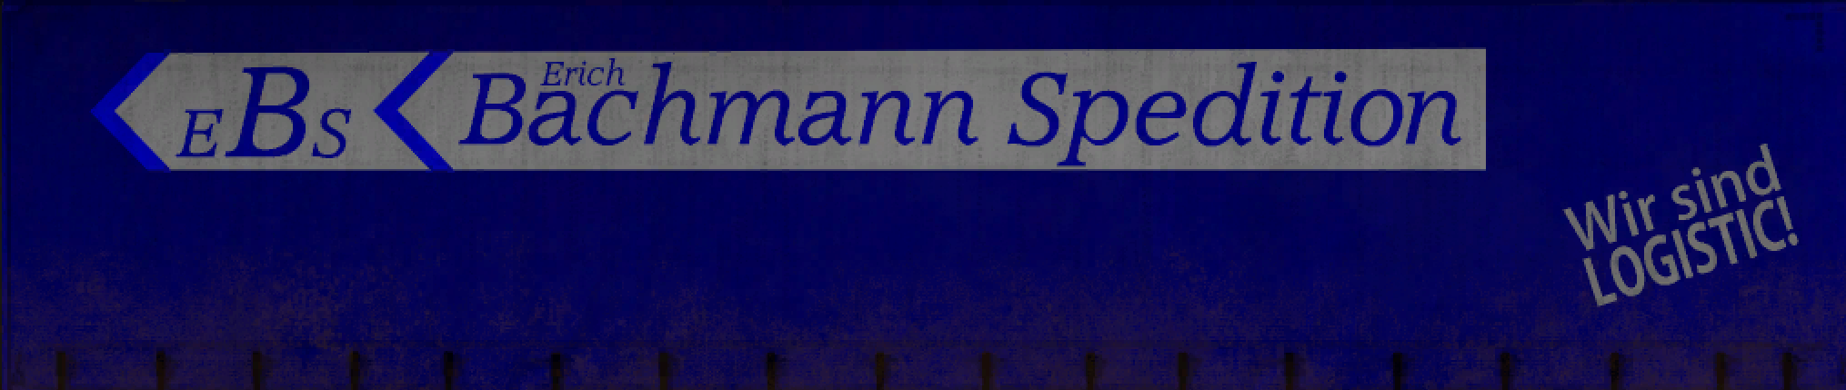

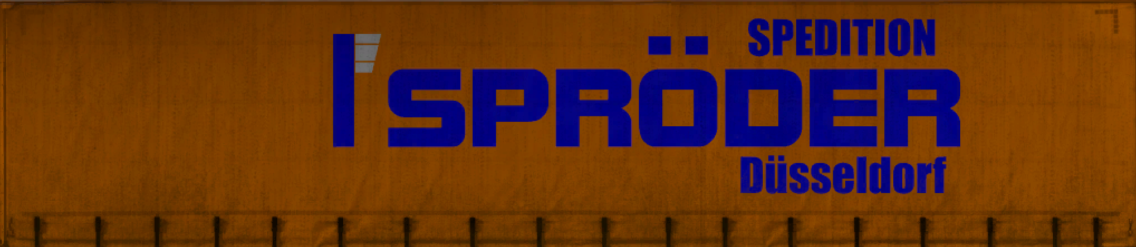

K-V default Back

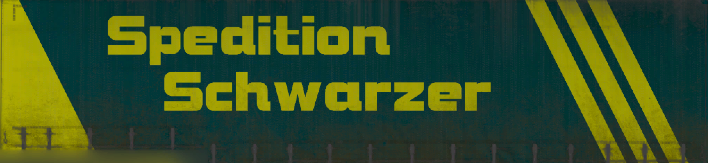



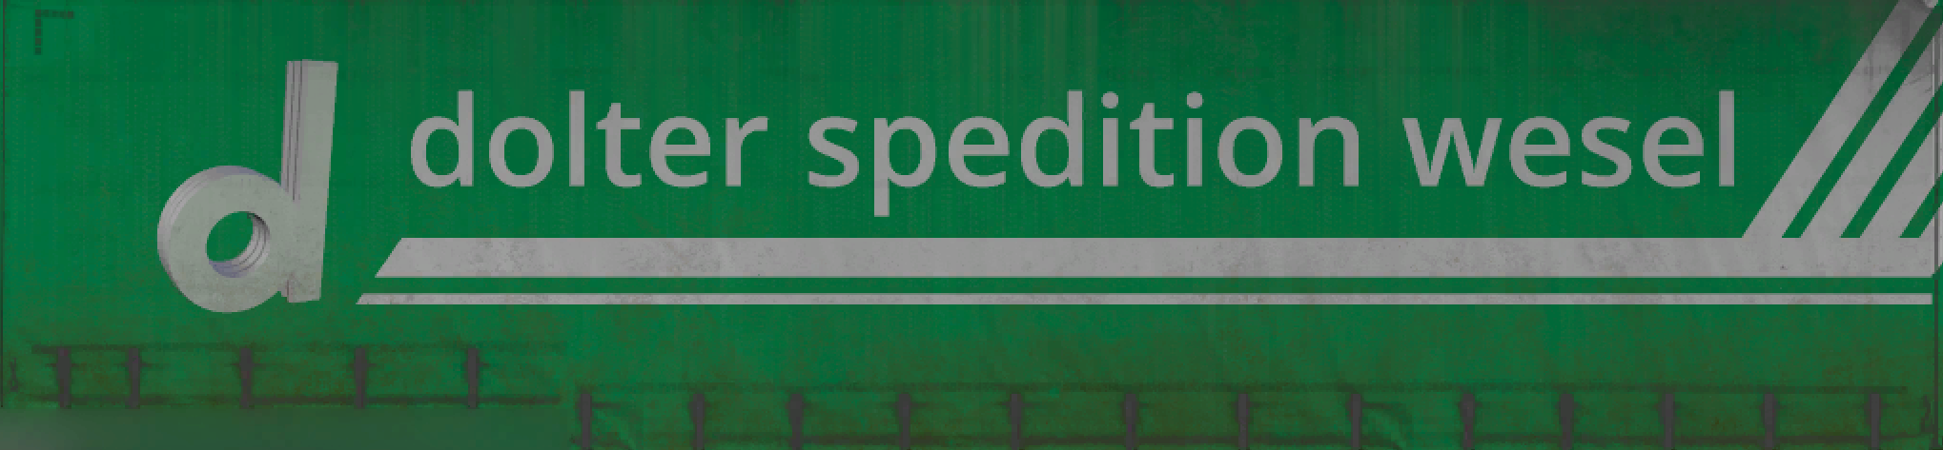

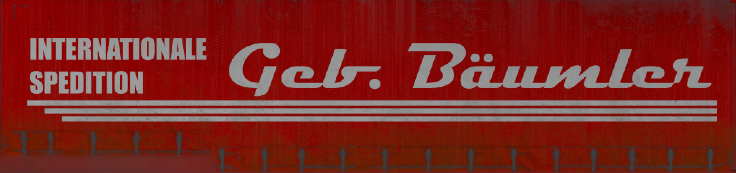

Arcese

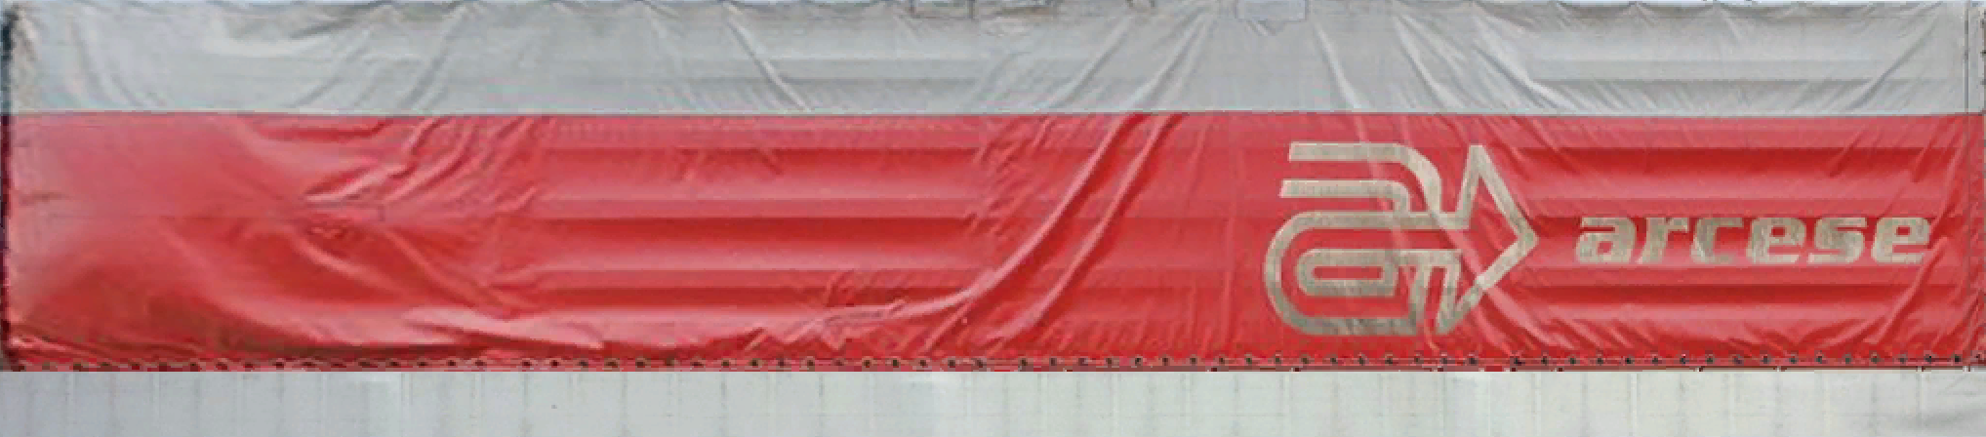

LKW Walter

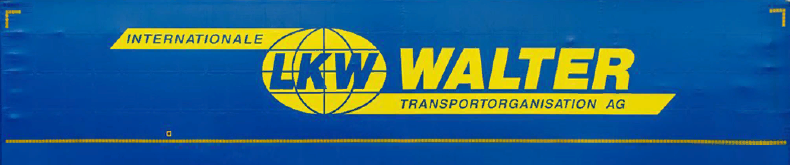

MARS



Schenker

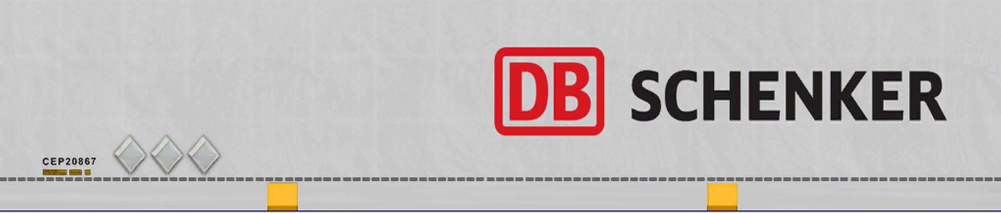

Thomaidis



Winner

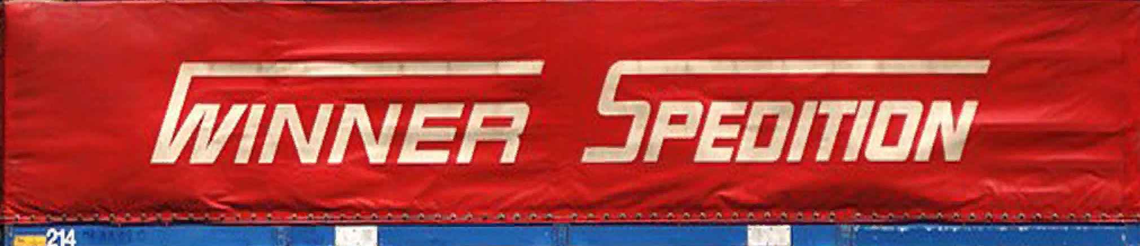

RailDesigns Container

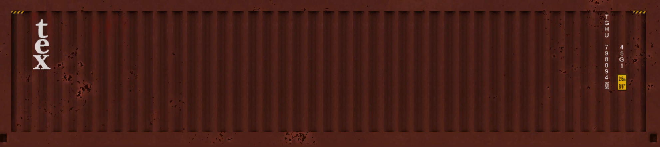



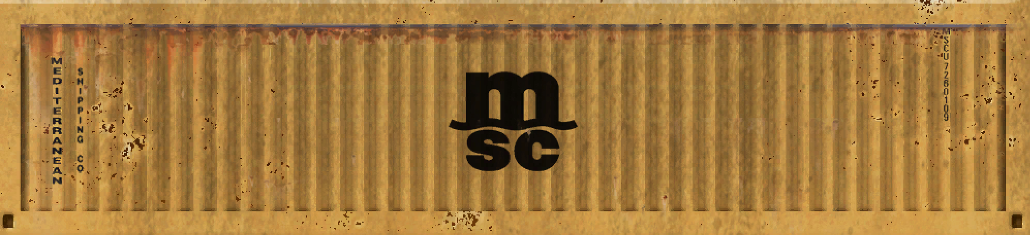

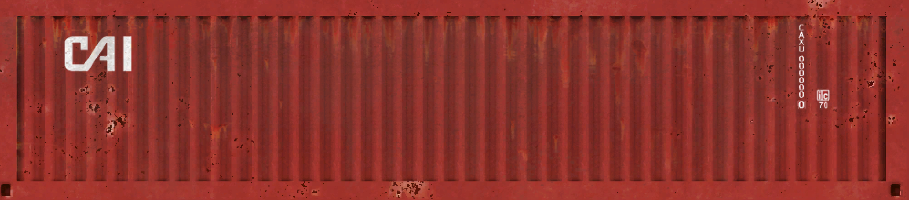

K-V default Cont

